BRITISH COLUMBIA INSTITUTE OF TECHNOLOGY
School of Computing and Academic Studies | Lab#4B
Program: Computer Systems Technology | COMP 7615 Cryptographic Methods
Instructor: Dr. Abhijit Sen | Due Date November 3rd,2009

- Using DES with CrypTool :

In this exercise we will focus on modern ciphers, primarily on the most prominent block cipher DES. We will study a relationship between DES and its extension 3-DES (triple DES). Recall, 3-DES was introduced in order to compensate for a short encryption key (only 56 bits) in the original DES cipher. 3-DES is still widely used for protection of data confidentiality. In October 2000, Rijndael encryption algorithm (AES) was chosen as a more robust and more flexible replacement of the DES encryption algorithm.
Similar to DES, AES is also a block cipher but it supports a variable block length and a variable key length (i.e., 128, 192 and 256 bits).
We will further study two basic operation modes of block ciphers, namely, ECB and CBC. More specifically, we will show that it is possible to rearrange the ECB and CBC cipher text blocks in such a way that all (or some) of the blocks decrypt correctly. This is a well-known cut-and-paste attack.
  - Histogram Analysis of the Data Encryption Standard

In this task we compare a frequency histogram of a document before and after encryption with the DES cipher. We use CrypTool to accomplish this. Quoting CrypTool help: “The histogram of a document expresses the frequency distribution of the characters of a document in graphical form in a corresponding window.” Create a new document in CrtypTool and fill it with a longer English text.

“ No one would have believed in the last years of the nineteenth century that this world was being watched keenly and closely by intelligences greater than man’s and yet as mortal as his own; that as men busied themselves about their various concerns they were scrutinized and studied, perhaps almost as narrowly as a man with a microscope might scrutinize the transient creatures that swarm and multiply in a drop of water. With infinite complacency men went to and fro over this globe about their little affairs, serene in their assurance of their empire over matter. Alternatively, open an existing English text. ”

Save this document for later reference.

- In the main menu, click on the “View” submenu and select “ Show As HexDump”.

This is to convert ASCII representation of the plaintext document into the corresponding hexadecimal representation (Figure 1).

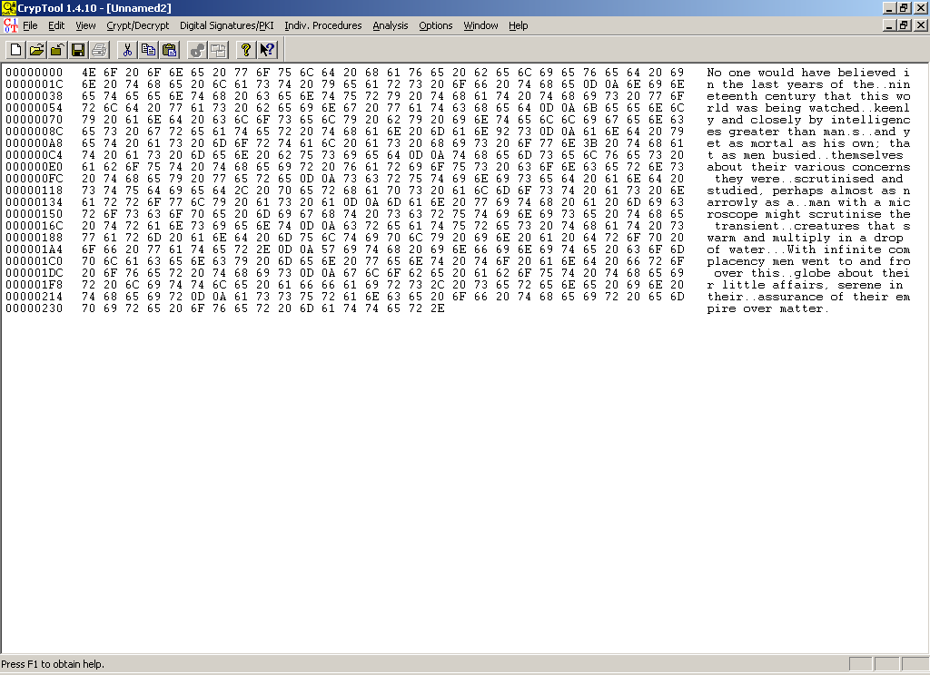

Figure 1: Hexadecimal representation of an ASCII text.

- In the main menu, open the “Analysis” submenu and select “Tools for Analysis -> Histogram” to obtain the histogram of the plaintext (un-encrypted) document (Figure 3). Save the result.

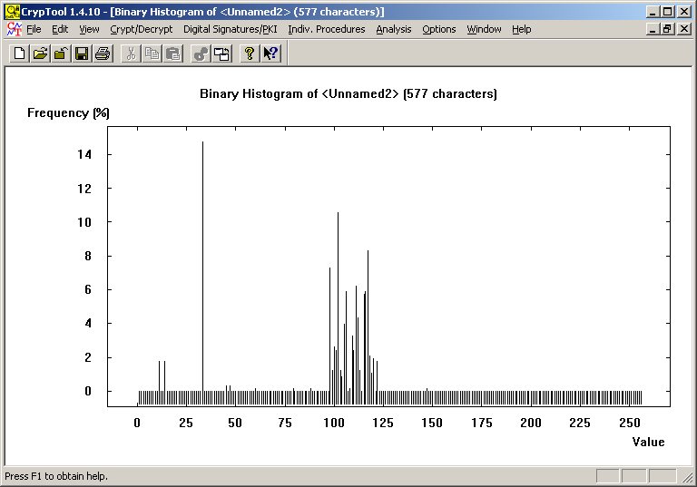

Figure 2: Histogram of an unencrypted message (DES cipher).

- Encrypt the plaintext document (English text) using the DES cipher.
- In CrypTool click on the window with the plaintext document in order to make it active.
- In the main menu, under the “Crypt/Decrypt” submenu select “Symmetric modern) . DES CBC...”.
- Enter the encryption key and encrypt the plaintext document (Figure 3).

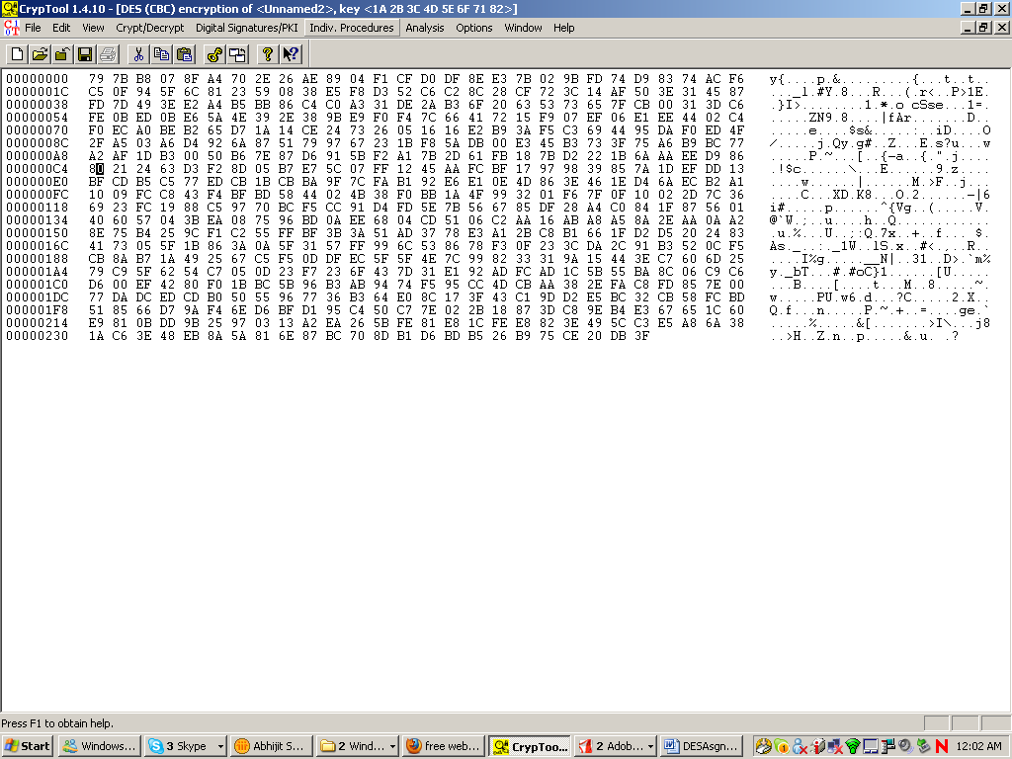

Figure 3: Hexadecimal representation of an ASCII text.

- In the main menu, open the “Analysis” submenu and select “Tools for Analysis ->Histogram” to obtain the histogram of the encrypted text (ciphertext).document (Figure 4). Save the result.

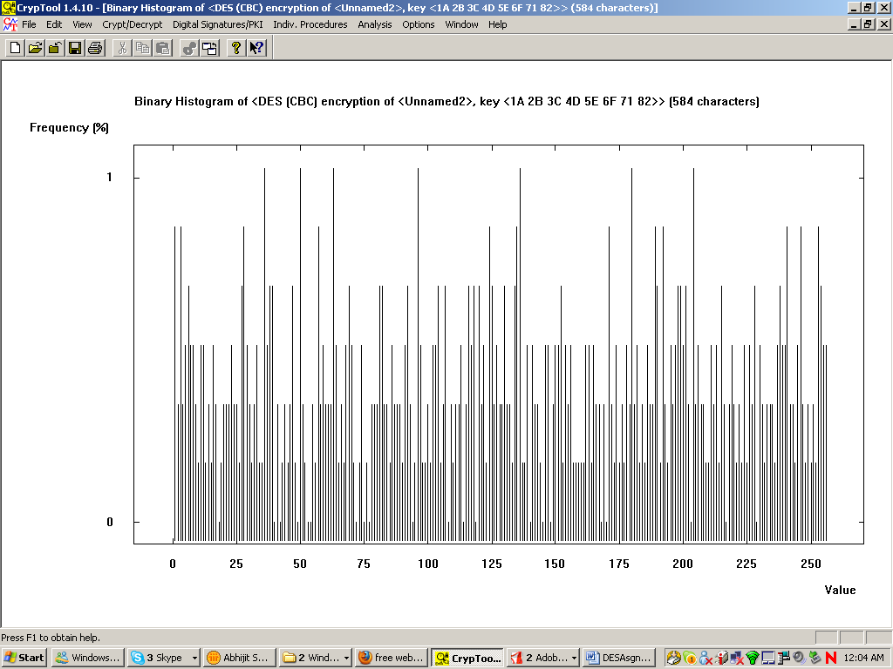

Figure 4: Histogram of a cipher text message (DES cipher)

- Compare the result with the histogram obtained for plaintext (Figure 2) and cipher text (Figure 4). Describe/explain your observations.

  - Avalanche Effect

Avalanche effect means a small change in the plaintext or key should create a significant change in the ciphertext. DES has been proven to be strong with regard to this property.

- To verify avalanche effect, encrypt two plaintext blocks with the same key with DES in the ECB mode as given below:

Plaintext 1: 0011223344ABCDEF
Plaintext 2: 1011223344ABCDEF
Key : ABCDEFFEDCBA1234
Note: the plaintexts differ in only one bit.
Observe and analyse the differences between bits in both ciphertexts.

- To verify avalanche effect, encrypt a plaintext block with two keys with DES in the ECB mode as given below:

Plaintext 1: 3311223344ABCDEF
Key 1 : ABCDEFFEDCBA1234
Key 2 : ABCDEFFEDCBA1235
Note: the keyss differ in only one bit.
Observe and analyse the differences between bits in both ciphertexts.

Observe and analyse the differences between bits in both ciphertexts.

  - Triple DES (3-DES)

- Assume that a message m is encrypted using 3-DES (in the ECB mode) with the following key (hex value):

K = 11 22 33 44 55 66 77 88 AA BB CC DD EE FF FF FF

The encrypted message is to be decrypted using only regular 1-DES (in the ECB mode, AND not 3-DES ECB mode).
Explain how this is done.

- Use CrypTool and encrypt your name with 3-DES in the ECB mode under the following two encryption keys to generate two ciphertexts:

K1 = 11 22 33 44 55 66 77 88 AA BB CC DD EE FF FF FF
K2 = 11 22 33 44 55 66 77 88 11 22 33 44 55 66 77 88

Decrypt resulting cipher texts using 1-DES cipher in the ECB mode.
One among the keys K1 and K2 enables “fast” decryption with the 1-DES cipher (a single application of 1-DES). Which one? Please explain your answer.

- Consider the following message M:

M=Bob’s salary is $25000--Tom’s salary is $15000

Break the message (plaintext) up into 64 bit long plaintext segments (M₁ M₂...M_{k}). Note that each letter in the message is an 8 bit ASCII character and each “space” (blank) counts as a single ASCII character (20 Hex).

- Using CrypTool, encrypt message M with DES in the ECB mode using key

K = 11 22 33 44 55 66 77 88
Write down resulting 64 bit ciphertext blocks C₁ C₂... C_{k}.

- Exchange cipher text blocks C1 and C4 in the above sequence of cipher text blocks to obtain the following sequence of cipher text blocks: C₄ C₂ C₃ C₁ C₅... C_{k}

Decrypt the resulting cipher text using the key

K = 11 22 33 44 55 66 77 88

What message do you obtain? Please explain.

  - Submission Requirements:

Please submit the document in the share drive.

  - Submit a professionally formatted report (Word document) containing the following:

- Cover page with your:
  - full name
  - email address
  - student id number
  - Lab #
  - Date of Submission
- Section 1:Purpose:
- Section 2:Procedures: Step by step description of your procedures with Screen Shots
- Section 3:Discussion: Clearly discuss the result and your observations for each procedures
- Section 4 Conclusion

  - Name the word file as :

Crypto_L4B_ Lastname_Initial.doc

